Networking Revision
name

2022
List All Private IP Address Ranges
10.0.0.0 | To | 10.255.255.255
172.16.0.0 | To | 172.31.255.255
192.168.0.0 | To | 192.168.255.255

Describe what Attenuation is concerning networked signals.
It is a reduction in signal strength as it goes through cables, air and other materials.

Name all the OSI layers and describe what each layer does
1 | Physical Layer | Physical Layer Handles the actual transmission of raw bits over a physical medium.
2 | Data Link Layer | Ensures error-free node-to-node delivery. Encapsulates packets into frames, adds MAC addresses, and manages flow control and error detection
3 | Network Layer | Responsible for logical addressing (IP addresses) and routing packets between devices across networks.
4 | Transport Layer | Provides end-to-end communication, segmentation/reassembly, and error recovery. Uses TCP (reliable, connection-oriented) or UDP (faster, connectionless). Adds port numbers for service identification.
5 | Session Layer | Manages establishing, maintaining, and terminating sessions between applications
6 | Presentation Layer | Acts as a translator between application and network formats. Handles data translation, encryption/decryption, and compression
7 | Application Layer | Closest to the user, providing network services to applications. Supports protocols like HTTP, FTP, SMTP, DNS.

How many usable IP addresses does each subnet have?
/30 | 2 Usable Addresses
/29 | 6
/28 | 14
/27 | 30
/26 | 62
/25 | 126
/24 | 254
/23 | 510
/22 | 1022
/21 | 2046
/20 | 4094

IP Default Subnet Masks for Address Classes A, B and C
11111111 00000000 00000000 00000000 | 8/24
11111111 11111111 00000000 00000000 | 16/16
11111111 11111111 11111111 11111111 | 24 / 8
How many bits are in ipv4 and ipv6 addresses?
IPV4 | 32
IPV6 | 128

Describe what this image is and what cable it connects to, how many pins does it have?
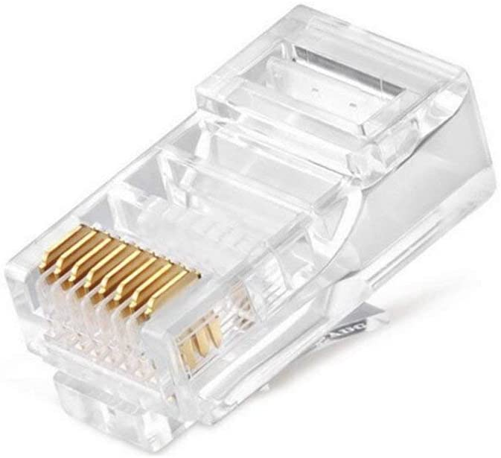

RJ45 plug connects ethernet cables CAT5E, CAT6 and CAT7. It contains 8 pins.

Describe the networks.
MAN | Metropolitan Area Network, is a high-speed computer network that connects multiple LANs within a city or metropolitan area
PAN | Personal Area Network, short-range network that connects devices within an individual’s immediate workspace, enabling communication and data exchange among personal devices
WAN | Wide Area Network, covers a large geographical area and connects multiple smaller Local Area Networks (LANs) or Metropolitan Area Networks (MANs).
LAN | A Local Area Network, connects multiple devices within a limited geographical area, such as a home, office, or campus

Explain the difference between Telnet and SSH when connecting to a network.
SSH (Secure Shell) and Telnet are both network protocols used for remote device management.
SSH allows secure remote login, command execution, and file transfer over insecure networks.
Telnet transmits data in plain text, making it vulnerable to packet sniffing and man-in-the-middle attacks

What is the purpose of a router and explain how packets are sent from source to destination?
A router is a networking device that connects multiple networks.

When a data packet is received by a router, it reads the IP header to determine the destination. The router then consults its routing table to find the most efficient path to the destination.

Explain the transmission modes
Simplex | Simplex transmission is a one-way communication method where data flows from the sender to the receiver only
Half Duplex | Half-duplex transmission allows data to flow in both directions, but only one direction at a time.
Full Duplex | Full duplex transmission allows two devices to send and receive data simultaneously, enabling faster and more efficient communication

Explain the IEEE standards
802.3 | IEEE 802.11: This standard, commonly known as Wi-Fi, defines the architecture and specifications for wireless local area networks (WLANs). It allows devices to communicate wirelessly, enabling internet access without physical cables
802.11 | his standard covers personal area networks (PANs), which include technologies like Zigbee and Bluetooth. It focuses on low-power wireless communication for devices in close proximity
802.15 | This standard is part of the Ethernet family, which provides wired network connections. It has evolved to support higher data rates and is widely used in data centers and enterprise environments for stable and reliable connections

A router can offer IP addresses to all connected hardware automatically using DHCP. Give the full name of the acronym and explain.
Dynamic Host Configuration Protocol. It is a network management protocol used for automatically assigning IP addresses and other communication parameters to devices connected to a network

Network Topologies explain each, what topology has the most redundancy?
Bus | This topology provides the highest redundancy and fault tolerance. All nodes are connected to each other, ensuring that data can continue to flow even if one link fails
Star | While it offers high redundancy, it is not as robust as the bus topology. In a star topology, all nodes are connected to a central hub, which can become a bottleneck if the hub fails.
Ring | This topology provides good fault tolerance and communication between clusters, but it can become complex and expensive to maintain as the network grows.
Mesh | This topology provides the highest redundancy and fault tolerance, but it can become complex and expensive to maintain as the network grows.

What are ICMP PING responses and what does the acronym ICMP stand for?
ICMP stands for Internet Control Message Protocol, which is a network layer protocol used to send error messages and operational information about network conditions. It is primarily used for diagnostic purposes.

Why does a CAT 6 cable have 4 twisted pairs?
A CAT 6 cable has 4 twisted pairs because this design is crucial for high-speed data transmission. The twists in the pairs help to reduce electrical interference and prevent crosstalk, allowing for reliable communication over longer distances.

List all Classful IP Address Ranges
0.0.0.0 | TO | 127.255.255.255
128.0.0.0 | TO | 191.255.255.255
192.0.0.0 | TO | 223.255.255.255
224.0.0.0 | TO | 239.255.255.255
240.0.0.0 | TO | 255.255.255.255

What is the primary reason for implementing CRC and FCS in network communications?
To ensure data integrity and prevent data corruption during transmission. These techniques are essential for error detection and recovery, as they allow network devices to detect and handle errors that may occur during data transmission.
Which methods at the OSI Data Link layer ensure error-free data transmission across a LAN?
The Data Link Layer employs mechanisms like Automatic Repeat Request (ARQ) to detect errors and correct them if necessary.
At which layers of the TCP/IP protocol stack can IPsec be implemented?
IPsec can be implemented at the network layer
What is the primary function of a network switch?
The primary function of a network switch is to receive data from connected devices and transmit it to the appropriate destination
Which device makes forwarding decisions based on IP addresses?
Router
What does the acronym SSH stand for?
Secure Shell
If you are using port 22 to manage a network device, what activity are you likely performing?
Secure Shell (SSH) connections
What is the main function of a network repeater?
The main function of a network repeater is to regenerate and retransmit signals to extend the reach of data transmission. This is achieved by amplifying the signals to overcome the problem of signal attenuation
What information is included in a Layer 2 frame header?
Preamble, Start frame delimiter, destination MAC address, source MAC address, EtherType, Payload, Frame Check Sequence (FCS).
What is the purpose of the window size field in OSI layer 4?
Efficient data transfer and flow control
What is the correct sequence of the encapsulation process in the TCP/IP model from top to bottom?
Application Layer
Transport Layer
Network Layer
Data Link Layer
Physical Layer

